First Code App Run the app locally - Create a code app using the Power Apps CLI

Step 1: Create the project
Open Visual Studio
Terminal New Terminal move to Project folder
PS C:\Development\CodeApps>
Run following comment
npx degit github:microsoft/PowerAppsCodeApps/templates/vite first-app
cd first-app
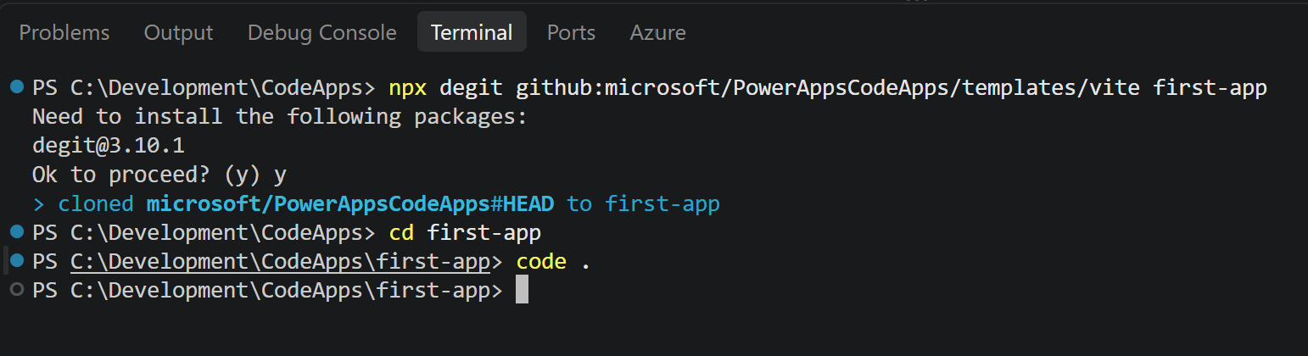
Open the Project in Visual Studio Code using code.
Step 2: Install dependencies and initialize the code app
Install the Power Apps CLI and the project dependencies:
npm install --global @microsoft/power-apps-cli
npm install --global @microsoft/power-apps
npm install
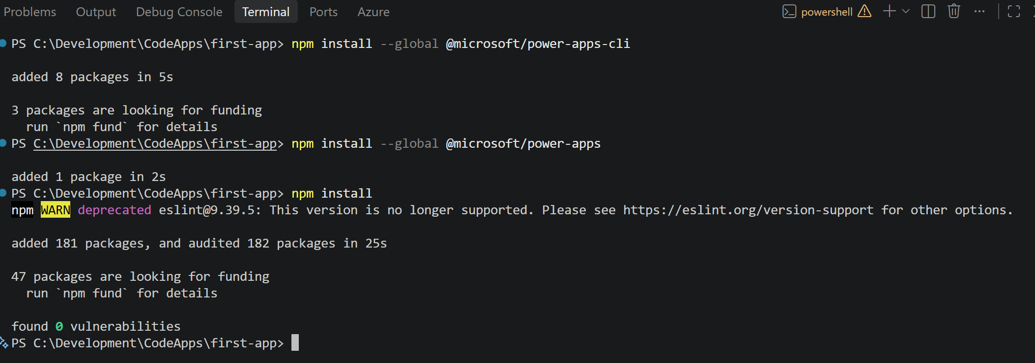
Start the app
pa app init
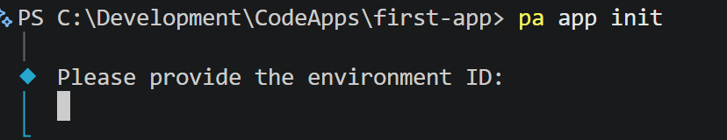
Get the environment ID from your Power Apps your environment
Make.Powerapps.com Settings Session details
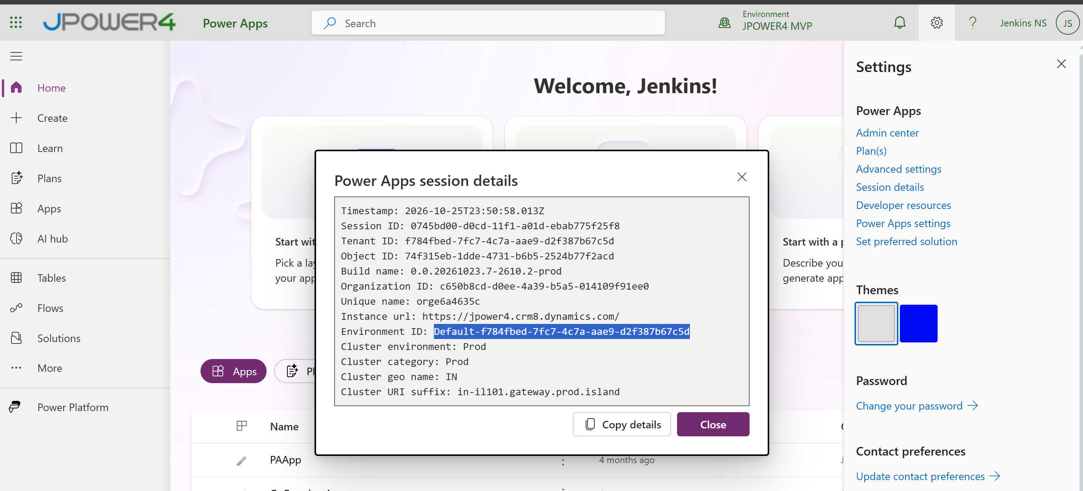
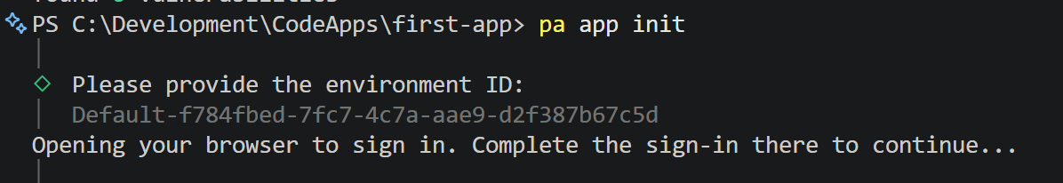
It opens a browser and login

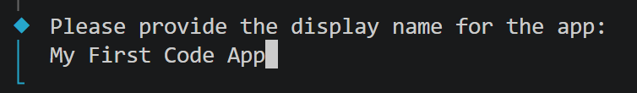
Enter Display Name for your app
Run the app pa app run
Copy and Paste the url in the browser
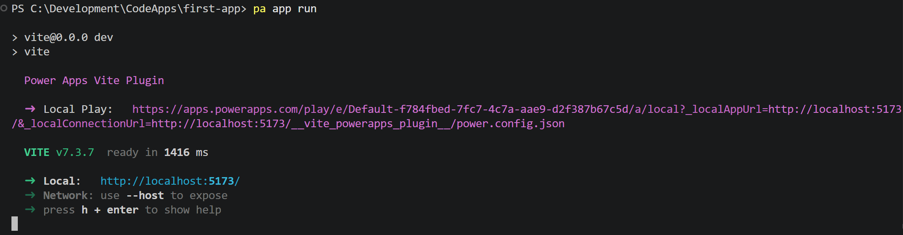
https://apps.powerapps.com/play/e/Default-f784fbed-7fc7-4c7a-aae9-d2f387b67c5d/a/local?_localAppUrl=http://localhost:5173/&_localConnectionUrl=http://localhost:5173/__vite_powerapps_plugin__/power.config.json

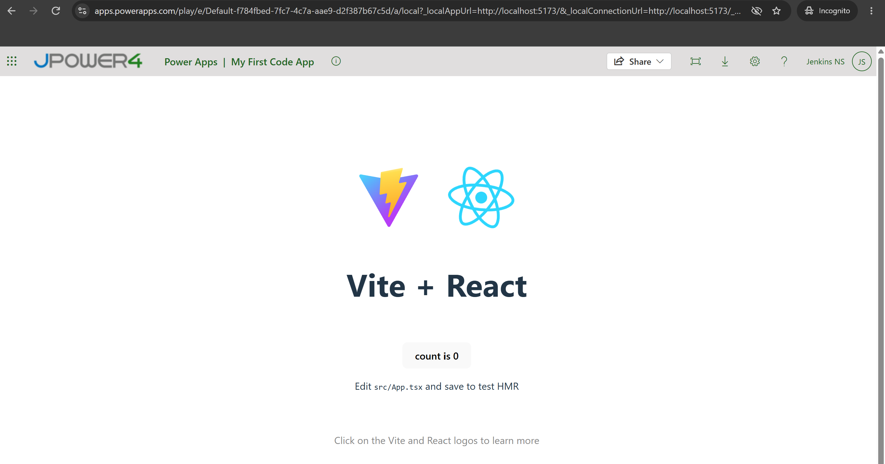

Then we add small Mock data using react code
Open App.tsx file and replace the below code
import React from "react";
import "./App.css";
interface Account {
accountNumber: string;
accountName: string;
balance: number;
}
interface Transaction {
id: number;
date: string;
description: string;
type: "Credit" | "Debit";
amount: number;
}
const account: Account = {
accountNumber: "1234567890",
accountName: "John Doe",
balance: 125000,
};
const transactions: Transaction[] = [
{
id: 1,
date: "2026-10-20",
description: "Salary Credit",
type: "Credit",
amount: 50000,
},
{
id: 2,
date: "2026-10-21",
description: "Electricity Bill",
type: "Debit",
amount: 2500,
},
{
id: 3,
date: "2026-10-22",
description: "Online Shopping",
type: "Debit",
amount: 4500,
},
{
id: 4,
date: "2026-10-23",
description: "Interest Credit",
type: "Credit",
amount: 1200,
},
];
function App() {
return (
<div className="container">
<h1>🏦 Banking Dashboard</h1>
<div className="account-card">
<h2>Account Summary</h2>
<p>
<strong>Name:</strong> {account.accountName}
</p>
<p>
<strong>Account No:</strong> {account.accountNumber}
</p>
<p className="balance">
₹{account.balance.toLocaleString()}
</p>
</div>
<div className="transaction-section">
<h2>Recent Transactions</h2>
<table>
<thead>
<tr>
<th>Date</th>
<th>Description</th>
<th>Type</th>
<th>Amount</th>
</tr>
</thead>
<tbody>
{transactions.map((txn) => (
<tr key={txn.id}>
<td>{txn.date}</td>
<td>{txn.description}</td>
<td
style={{
color:
txn.type === "Credit"
? "green"
: "red",
}}
>
{txn.type}
</td>
<td>₹{txn.amount.toLocaleString()}</td>
</tr>
))}
</tbody>
</table>
</div>
</div>
);
}
export default App;

Then Open App.css file and add below css code
body {
margin: 0;
font-family: Arial, sans-serif;
background: #f5f7fb;
}
.container {
padding: 30px;
max-width: 1000px;
margin: auto;
}
h1 {
color: #003366;
}
.account-card {
background: white;
padding: 20px;
border-radius: 10px;
margin-bottom: 25px;
box-shadow: 0 2px 10px rgba(0, 0, 0, 0.1);
}
.balance {
font-size: 28px;
color: green;
font-weight: bold;
}
.transaction-section {
background: white;
padding: 20px;
border-radius: 10px;
box-shadow: 0 2px 10px rgba(0, 0, 0, 0.1);
}
table {
width: 100%;
border-collapse: collapse;
}
th {
background: #003366;
color: white;
padding: 10px;
}
td {
padding: 10px;
border-bottom: 1px solid #ddd;
}
tr:hover {
background: #f2f2f2;
}
And open the browser you can see the update there
